**My Digital Library Information System**

**Project Overview**

My Digital Library Information System is a console-based application that consist of various features as follows:

* Perform CURD Operations
* Store Books Based on Categories
* Search Book Based on Category, Author Name and Book Title
* Smooth Architecture
* Save Records with Unique ID
* Import data from binary file and write to CSV
* Export CSV data to Binary

My Digital Library is a smooth application built with smooth architecture. The whole application is divided into four main classes:

1. **BookModel:** It contains books schema and schema related member functions.
2. **Utility:** It holds utility functions i.e., reading-writing to binary & CSV files, frontend menus etc.
3. **BACKEND:** This class is designed to perform the CURD operations and handle the application logic i.e., search methods etc.
4. **FRONTEND:**  It is responsible for displaying the contents to the console.

Beside these four classes, the system also includes various helper functions as follows:

1. **handleFristTimeRun():** It is designed to run only if we have no record available in BookModel.bin file or when file doesn’t exist because complete system is based on this single file BookModel.bin and all interactions occur only if we have some records in it, so it’s crucial to have some records initially to perform some interactive tasks.
2. **RunApp():** This function is entry point of the system which initialize the whole application, it uses FRONTEND object and call f.home_page() method and then control goes with going.

The source code is well structured and well commented, to get started with it, first you need to give some records that will store into binary file and then you can start interaction with the application. There is proper validation for everything, on every error program will throw an exception, some time it may stop the execution of the program and sometimes an exception just inform you about the error.

**How to use it?**

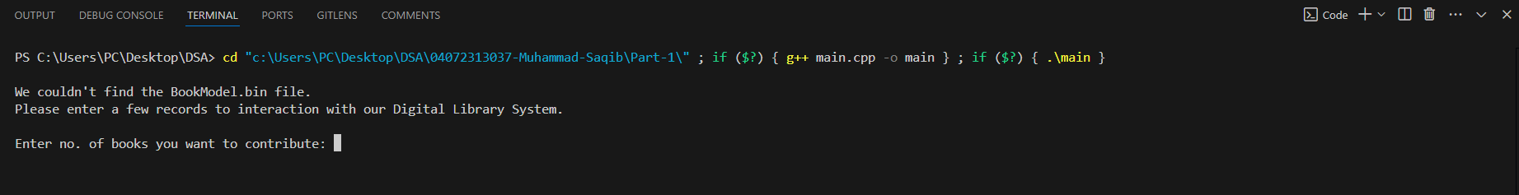**First time Run:** When you will start application for first time, the following screen will pop up and, it will ask you to enter few records to start interaction with our system, if you will enter bad type, other than integer then it will terminate the program and displaying the error type, so, be careful while entering the integers values to avoid program termination.

**Welcome Screen:** If you will enter correct integer, then program will ask you to enter few records and program will save those records to BookModel.bin file and after records would be saved the next welcome screen will appear with several options as shown in following image.

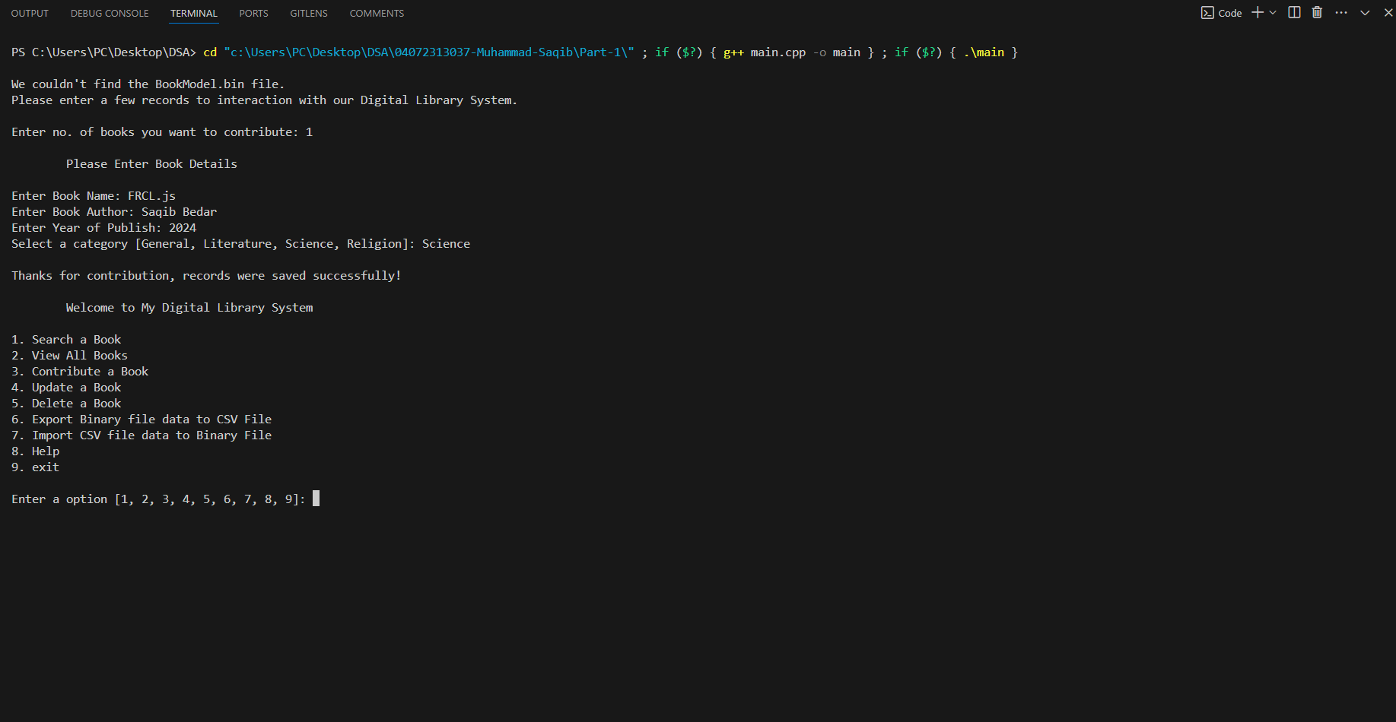

**Welcome Screen Options:** It has nine options for interaction and option is properly validated incase if you enter a bad type then program will get terminated, so be careful while entering the option, only use integers.

1. 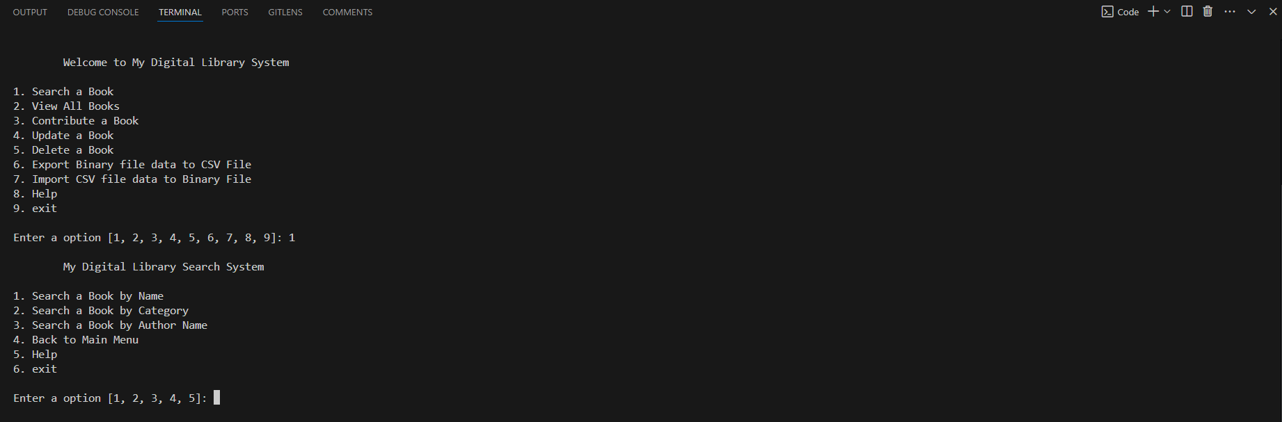**Search a Book:** Option 1 will take you to the My Digital Library Search System page where you can search any book by its name, author or category. Search system page has also several options for interactions i.e., Back to Main Menu will redirect you to the home page, help option navigate you to My Digital Library Help Center page and exit as shown in this image will close the program.
2. **View All Book:** Option 2 will display all the records avaible in in file.
3. **Contirbute a Book:** Option 3 will ask you enter the enter the no. of books you want to contribute and then it will read the records from you, after reading the records it will save all the records to binary file.
4. **Update a Book:** Option 4 will ask you to enter the index of the record you want to update and if index would be valid, it will process your request and if record would be available in the database, then update logic will start to update the record.
5. **Delete a Book:** Option 5 will delete any record based on the given index.
6. **Export Binary data to CSV file:**  Option 6 will fetch all the data from binary and write it to the BookModel.csv file.
7. **Import CSV file data to Binary:** Option 7 will load csv data into BookModel.bin file.
8. 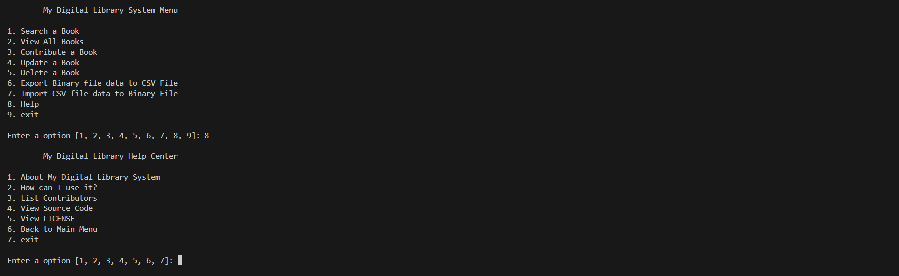**Help:** Option 8 will bring you to the My Digital Library Help Center where you can navigate through many options i.e., option 1 ‘About My Digital Library System’ will display the about information of My Digital Library, option 2 ‘How can I use it’ will give you instructions about how to use the program, option 3 will list the all contributors of the project, option 4 will display the repository link of this project, option 5 will show you the LICENSE of this project, option 6 will again redirect you to the home page and last option exit the program.
9. **Exit:** Option 9 will exit the program.

**THANKS**